Church Street Main Drain Rehabilitation

**Completion works commencing in May 2025**

At Melbourne Water we manage 1,400 kilometres of regional drains that connect to local drains and street gutters, managed by local councils. Our drainage system safely carries stormwater away from built-up areas into rivers and creeks; allowing us to minimise the damage floods can cause to people, places and communities.

# Drainage works in your area

Aqua Metro, on behalf of Melbourne Water, will be conducting rehabilitation works to the Church Street Main Drain in Hawthorn, between Church Street and College Street.

This work will ensure the Church Street Main Drain can continue to operate safely for generations to come.

# Timing of works

Works are expected to start in **May 2025** and take approximately one month to complete, weather permitting.

# Location of works

Majority of these works will take place in maintenance holes located within the Smart Street Reserve in Hawthorn.

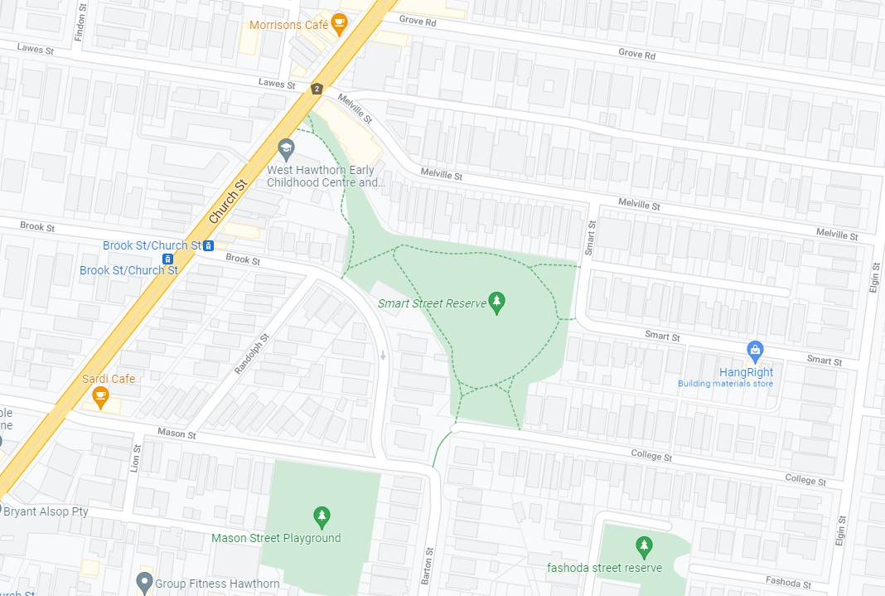

Work area

# What to expect

Our staff will be accessing the underground stormwater drain through Melbourne Water maintenance holes. As we conduct works, you will notice temporary cyclone fencing and machinery set up around the maintenance holes.

We will make every effort to minimise impacts to community, however during works you may notice:

* Some dust.
* Increased construction noise.
* Increased vehicle movements in and out of the Smart Street Reserve.
* Some temporary pathway diversions within the Smart Street Reserve.

Please note, that during these works there will be no disruption to your water supply.

We thank you for your support during these important works.

